**Advaitha 2nd year ece**

**Code**

int time_slot;  
void setup() {  
  // put your setup code here, to run once:  
  pinMode(2,OUTPUT);//signal1 red  
  pinMode(3,OUTPUT);//signal1 yellow  
  pinMode(4,OUTPUT);//signal1 green  
  pinMode(5,OUTPUT);//signal2 red  
  pinMode(6,OUTPUT);//signal2 yellow  
  pinMode(7,OUTPUT);//signal2 green  
  pinMode(8,OUTPUT);//signal3 red  
  pinMode(9,OUTPUT);//signal3 yellow  
  pinMode(10,OUTPUT);//signal3 green  
  pinMode(11,OUTPUT);//signal4 red  
  pinMode(12,OUTPUT);//signal4 yellow  
  pinMode(13,OUTPUT);//signal4 green  
  Serial.begin(9600);  
  Serial.println("enter time slot:");  
}  
  
void loop() {  
  // put your main code here, to run repeatedly:  
  while(Serial.available()==0){}  
  time_slot=Serial.parseInt();  
  Serial.println(time_slot);  
  if(time_slot==1)  
  {  
    digitalWrite(3,HIGH);  
    digitalWrite(6,HIGH);  
    digitalWrite(9,HIGH);  
    digitalWrite(12,HIGH);  
    digitalWrite(2,LOW);  
    digitalWrite(4,LOW);  
    digitalWrite(5,LOW);  
    digitalWrite(7,LOW);  
    digitalWrite(8,LOW);  
    digitalWrite(10,LOW);  
    digitalWrite(11,LOW);  
    digitalWrite(13,LOW);  
    delay(1000);  
  }  
  if(time_slot==2)  
{  
  digitalWrite(4,HIGH);  
  digitalWrite(5,HIGH);  
  digitalWrite(8,HIGH);  
  digitalWrite(11,HIGH);  
  digitalWrite(2,LOW);  
  digitalWrite(3,LOW);  
  digitalWrite(6,LOW);  
  digitalWrite(7,LOW);  
  digitalWrite(9,LOW);  
  digitalWrite(10,LOW);  
  digitalWrite(12,LOW);  
  digitalWrite(13,LOW);  
  millis(3000);  
  digitalWrite(3,HIGH);  
  digitalWrite(5,HIGH);  
  digitalWrite(8,HIGH);  
  digitalWrite(11,HIGH);  
  digitalWrite(2,LOW);  
  digitalWrite(4,LOW);  
  digitalWrite(6,LOW);  
  digitalWrite(7,LOW);  
  digitalWrite(9,LOW);  
  digitalWrite(10,LOW);  
  digitalWrite(12,LOW);  
  digitalWrite(13,LOW);  
  millis(1000);  
  digitalWrite(2,HIGH);  
  digitalWrite(7,HIGH);  
  digitalWrite(8,HIGH);  
  digitalWrite(11,HIGH);  
  digitalWrite(4,LOW);  
  digitalWrite(3,LOW);  
  digitalWrite(6,LOW);  
  digitalWrite(5,LOW);  
  digitalWrite(9,LOW);  
  digitalWrite(10,LOW);  
  digitalWrite(12,LOW);  
  digitalWrite(13,LOW);  
  millis(3000);  
  digitalWrite(3,HIGH);  
  digitalWrite(6,HIGH);  
  digitalWrite(8,HIGH);  
  digitalWrite(11,HIGH);  
  digitalWrite(4,LOW);  
  digitalWrite(2,LOW);  
  digitalWrite(5,LOW);  
  digitalWrite(7,LOW);  
  digitalWrite(9,LOW);  
  digitalWrite(10,LOW);  
  digitalWrite(12,LOW);  
  digitalWrite(13,LOW);  
  millis(1000);  
  }  
  if(time_slot==3)  
  {  
   digitalWrite(3,HIGH);  
  digitalWrite(7,HIGH);  
  digitalWrite(8,HIGH);  
  digitalWrite(13,HIGH);  
  digitalWrite(2,LOW);  
  digitalWrite(4,LOW);  
  digitalWrite(6,LOW);  
  digitalWrite(5,LOW);  
  digitalWrite(9,LOW);  
  digitalWrite(10,LOW);  
  digitalWrite(12,LOW);  
  digitalWrite(11,LOW);  
  millis(3000);  
  digitalWrite(3,HIGH);  
  digitalWrite(6,HIGH);  
  digitalWrite(8,HIGH);  
  digitalWrite(12,HIGH);  
  digitalWrite(2,LOW);  
  digitalWrite(4,LOW);  
  digitalWrite(5,LOW);  
  digitalWrite(7,LOW);  
  digitalWrite(9,LOW);  
  digitalWrite(10,LOW);  
  digitalWrite(11,LOW);  
  digitalWrite(13,LOW);  
  millis(1000);  
  digitalWrite(4,HIGH);  
  digitalWrite(5,HIGH);  
  digitalWrite(10,HIGH);  
  digitalWrite(11,HIGH);  
  digitalWrite(2,LOW);  
  digitalWrite(3,LOW);  
  digitalWrite(6,LOW);  
  digitalWrite(7,LOW);  
  digitalWrite(9,LOW);  
  digitalWrite(8,LOW);  
  digitalWrite(12,LOW);  
  digitalWrite(13,LOW);  
  millis(3000);  
  digitalWrite(3,HIGH);  
  digitalWrite(5,HIGH);  
  digitalWrite(9,HIGH);  
  digitalWrite(12,HIGH);  
  digitalWrite(4,LOW);  
  digitalWrite(2,LOW);  
  digitalWrite(6,LOW);  
  digitalWrite(7,LOW);  
  digitalWrite(8,LOW);  
  digitalWrite(10,LOW);  
  digitalWrite(11,LOW);  
  digitalWrite(13,LOW);  
  millis(1000);  
  }  
  if(time_slot==4)  
  {  
    digitalWrite(4,HIGH);  
  digitalWrite(5,HIGH);  
  digitalWrite(8,HIGH);  
  digitalWrite(11,HIGH);  
  digitalWrite(2,LOW);  
  digitalWrite(3,LOW);  
  digitalWrite(6,LOW);  
  digitalWrite(7,LOW);  
  digitalWrite(9,LOW);  
  digitalWrite(10,LOW);  
  digitalWrite(12,LOW);  
  digitalWrite(13,LOW);  
  millis(3000);  
  digitalWrite(3,HIGH);  
  digitalWrite(5,HIGH);  
  digitalWrite(8,HIGH);  
  digitalWrite(11,HIGH);  
  digitalWrite(2,LOW);  
  digitalWrite(4,LOW);  
  digitalWrite(6,LOW);  
  digitalWrite(7,LOW);  
  digitalWrite(9,LOW);  
  digitalWrite(10,LOW);  
  digitalWrite(12,LOW);  
  digitalWrite(13,LOW);  
  millis(1000);  
  digitalWrite(2,HIGH);  
  digitalWrite(7,HIGH);  
  digitalWrite(8,HIGH);  
  digitalWrite(11,HIGH);  
  digitalWrite(4,LOW);  
  digitalWrite(3,LOW);  
  digitalWrite(6,LOW);  
  digitalWrite(5,LOW);  
  digitalWrite(9,LOW);  
  digitalWrite(10,LOW);  
  digitalWrite(12,LOW);  
  digitalWrite(13,LOW);  
  millis(3000);  
  digitalWrite(3,HIGH);  
  digitalWrite(6,HIGH);  
  digitalWrite(8,HIGH);  
  digitalWrite(11,HIGH);  
  digitalWrite(4,LOW);  
  digitalWrite(2,LOW);  
  digitalWrite(5,LOW);  
  digitalWrite(7,LOW);  
  digitalWrite(9,LOW);  
  digitalWrite(10,LOW);  
  digitalWrite(12,LOW);  
  digitalWrite(13,LOW);  
  millis(1000);  
  }  
}

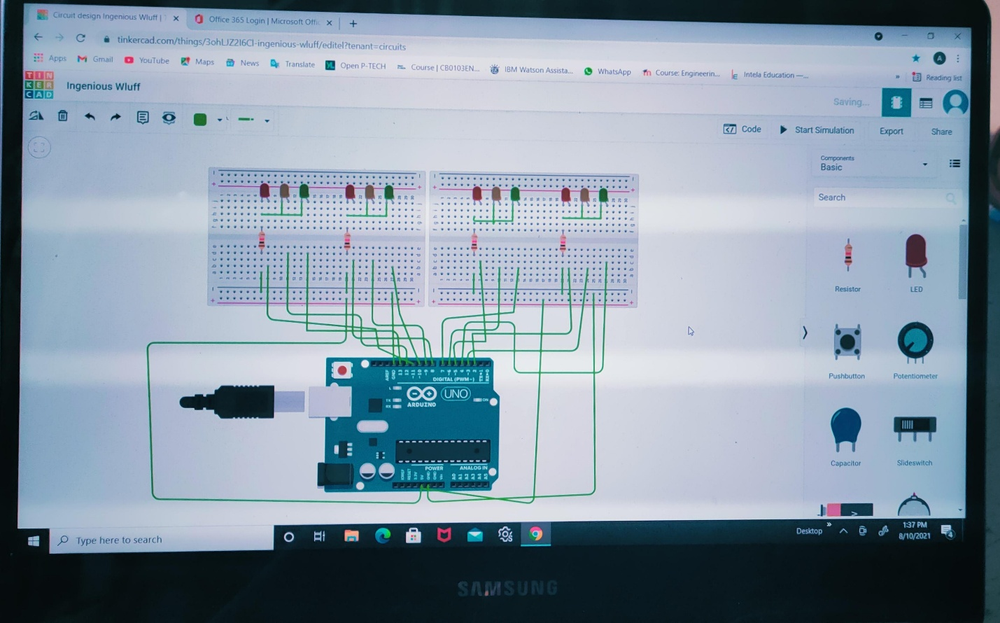**Screenshot**